Betsy M. McDowell, PhD, RN, CNE, ANEF
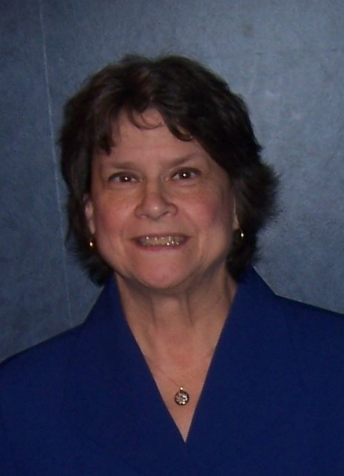
Professor Emerita of Nursing
Newberry College
Newberry, SC, USA
Neuman Systems Model Trustee since 2002
Currently Treasurer of NSMTG; also Chair of Abstract Review Committee for NSM Symposia
Areas of expertise with the Neuman Systems Model
Neuman-based baccalaureate nursing curriculum (NSM-based curricula at Lander University and at Newberry College); use of the NSM in pediatric nursing practice, including children who are victims of domestic violence
Areas of interest in providing consultation
Integration of the NSM into nursing curricula and use of the NSM in pediatric nursing practice
For further information, contact
Dr. Betsy M. McDowell
Cell: 864-980-5233
Betsy.McDowell@newberry.edu
Selected Neuman Systems Model publications
McDowell, BM. (2017). An example of teaching patient-centered care with children and families using a Neuman Systems Model Pediatric Assessment Tool (pp, 60-62), and The Neuman Systems Model Education Academy (pp. 264-265), in S Beckman and J Fawcett, Eds., The Neuman Systems Model: Celebrating Academic-Practice Partnerships, Neuman Systems Model Trustees Group, Inc.
McDowell, BM. (2011). Using the Neuman systems model to guide pediatric nursing practice (pp. 223-236). In B. Neuman and J. Fawcett (Eds.), The Neuman systems model, 5th ed. Philadelphia: Pearson.
McDowell, BM. (2006). Ask the expert: Caring for child-victims: Countering the effects of domestic violence. JSPN: Journal for Specialists in Pediatric Nursing, 11 (2), 127-130.
McDowell, BM, Chang, NJ, & Choi, SS. (2003). Children’s health retention in South Korea and the United States: A cross-cultural comparison. Journal of Pediatric Nursing, 18(6), 409-415.
Barnes-McDowell, BM. (1997). Home Apnea Monitoring: Family Functioning, Concerns, and Coping. (Doctoral dissertation, University of South Carolina, 1997), Dissertation Abstracts International, 58, 1205B.
Selected Neuman Systems Model presentations
McDowell, BM, “A Nursing Education Program Viewed through a Neuman Lens” (poster), 15th Biennial International Neuman Systems Model Symposium, Philadelphia, PA, June 2015.
McDowell, BM, “The Neuman Systems Model Applied to the Social Issue of Domestic Violence”, 14th Biennial International Neuman Systems Model Symposium, Vancouver, BC, Canada, June 2013.
McDowell, BM, “Actualization of the Neuman Systems Model as the Framework for a New Baccalaureate Nursing Program”, 13th Biennial International Neuman Systems Model Symposium, Lehigh Valley, PA, June 2011.
McDowell, BM, “Use of the Neuman Systems Model in Nursing Education”, Master of Advanced Nursing students, Hogeschool Utrecht, Holland, June 2010.
McDowell, BM, “Combating the Effects of Domestic Violence on Children Locally and Globally”, at Sigma Theta Tau International 40th Biennial Convention, Indianapolis, IN, November 2009.
McDowell, BM, “Meshing Family Centered Care with the Neuman Systems Model in Delivering Pediatric Nursing Care” at the 12th Biennial International Neuman Systems Model Symposium, Las Vegas, NV, June 2009.
McDowell, BM, “Asian-American Views on Child-Rearing: Assessing the Sociocultural Variable of the Neuman Systems Model” at the 10th Biennial International Neuman Systems Model Symposium, Akron, OH, April 2005.
Freese, BT, & McDowell, BM, “RN to BSN On-line Using the Neuman Systems Model” at the 9th Biennial International Neuman Systems Model Symposium, Willow Grove, PA, April 2003.
Gunter, TE, & McDowell, BM, “Body Piercing: Ancient Art, Modern Treatment” at the 9th Biennial International Neuman Systems Model Symposium, Willow Grove, PA, April 2003.
McDowell, BM, Chang, NJ, & Choi, SS, “Children’s Health Retention in South Korea and the United States: A Cross-cultural Comparison” at the 8th Biennial International Neuman Systems Model Symposium, Salt Lake City, UT, March 2001.
Barnes-McDowell, BM, “The Status of Children’s Health in Greenwood County” at Self Memorial Hospital Nursing Research & Ethics Committee, Greenwood, SC, July 1999 and at Mu Zeta Chapter of STTI Nursing Honor Society, Greenwood, SC, November 1999.
Freese, BT, & Barnes-McDowell, BM, “MEG’s Meeting: Dialog in Diversity” at the 7th Biennial International Neuman Systems Model Symposium, Vancouver, British Columbia, Canada, April 1999 (excerpted in Neuman News, 2000, vol. 4, no. 1, pp. 8-10).
Barnes-McDowell, BM, “Using the Neuman Systems Model to Address Children’s Health in a South Carolina County” at the 7th Biennial International Neuman Systems Model Symposium, Vancouver, British Columbia, Canada, April 1999.
Barnes-McDowell, BM, “Home Apnea Monitoring: Family Functioning, Concerns, and Coping”, at the 6th Biennial International Neuman Systems Model Symposium, Boston, MA, March 1997; also at the USC Graduate Student Day, Columbia, SC, April 1997, and at Self Memorial Hospital Nursing Research and Ethics Committee, Greenwood, SC, July 1997.
Freese, BT, Barnes, BM, Chang, NJ, & Hassell, J, “Application of the NSM to Baccalaureate Education”, presented by Nahn Chang at the Neuman Systems Model International Conference, Seoul, Korea, August 1995.
Freese, BT, Barnes, BM, Chang, NJ, & Hassell, J, “Application of the NSM to Education - Baccalaureate Workshop”, invited workshop at the 5th Biennial International Neuman Systems Model Symposium, Orlando, FL., February 1995.
Barnes, BM, “Neuman and NANDA: A Partnership for Nursing Practice”, poster presentation at the 5th Biennial International Neuman Systems Model Symposium, Orlando, FL, January 1995.

